Project design phase
Solution Architecture
Date | 1November2025
Team ID | NM2025TMID02619
Project Name | Calculating family Expenses using service now
Maximum Marks | 2Marks

Solution Architecture
Goals of the Architecture
- Provide a system safeguard using a Business Rule.
- Maintain data integrity across incident–user relationships.
- Reduce manual monitoring for user deletions.
Key Components
- sys_user table – stores user information.
- incident table – linked to users via the assigned_to field.
- Business Rule (Before Delete) – implemented on the sys_user table.
- Script logic – checks for active incident assignments before deletion.
Development Phases
- Create test users (e.g., Ajay, Kiran).
- Assign users to incidents.
- Implement the Business Rule.
- Attempt user deletion (test for both assigned and unassigned cases).

Solution Architecture Description
The solution architecture is designed to enforce data integrity and accountability in ServiceNow by preventing the deletion of users who are still associated with active incidents. The architecture leverages the native Business Rule framework on the sys_user table, ensuring seamless integration without the need for external plugins or dependencies.
When a deletion attempt is made on a user record, the “Before Delete” Business Rule is triggered. The script logic queries the incident table using the assigned_to field to check whether the user is currently assigned to any open incidents.
- If active incidents are found, the deletion process is blocked, and a descriptive error message is displayed to the administrator.
- If no active incidents exist, the deletion proceeds normally.
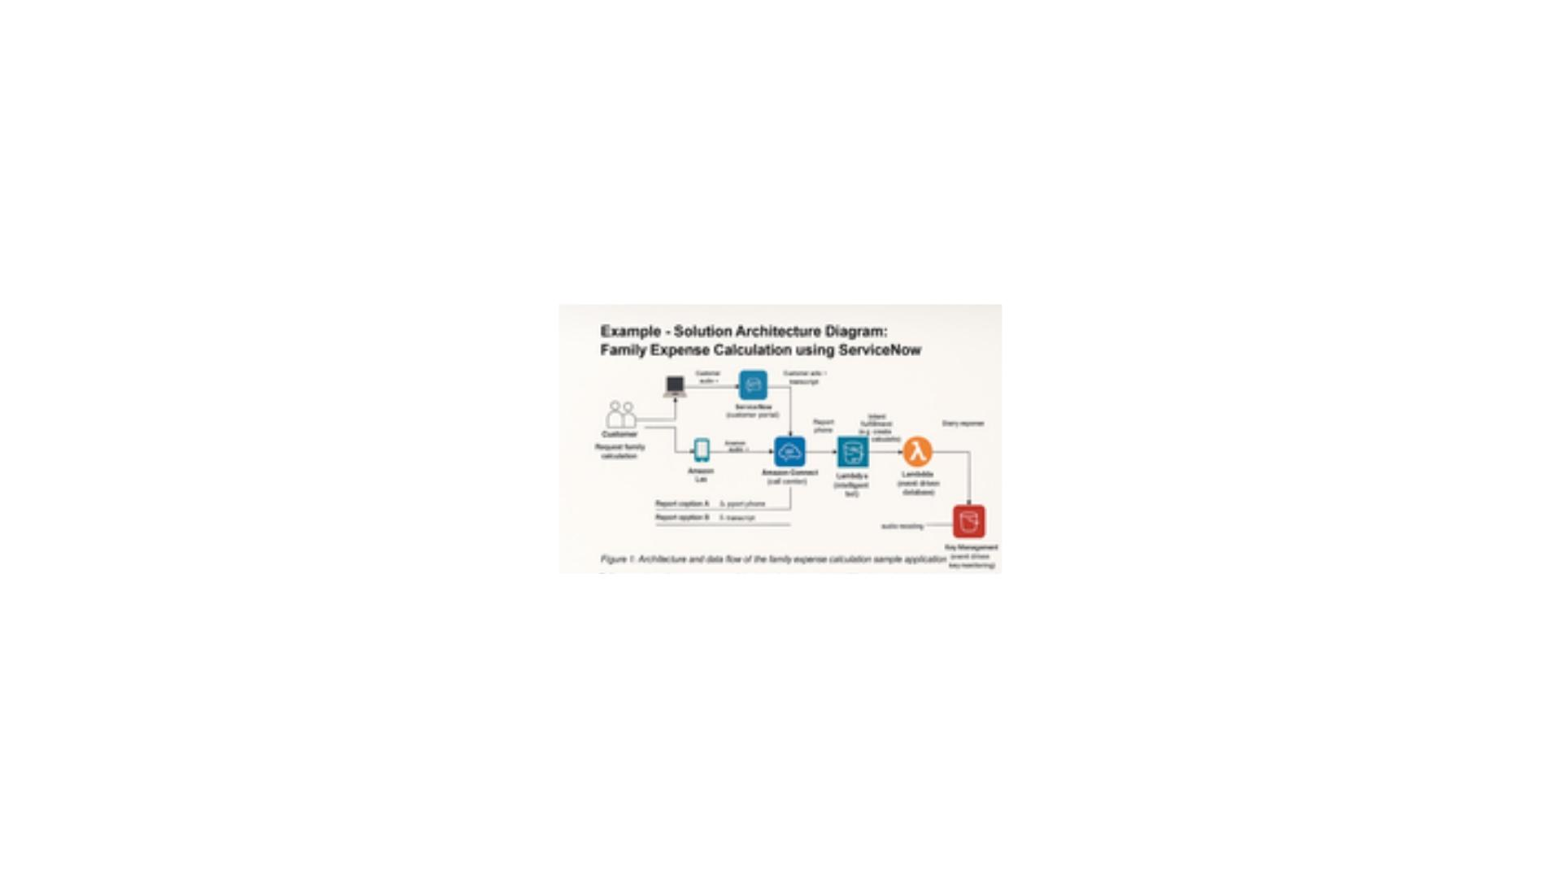
Solution Architecture Diagram
Reference: https://www.canva.com/design/DAG3nWYykaM/oQ4s0bCmX9RuFdQ5Hg5JCQ/edit?utm_content=DAG3nWYykaM&utm_campaign=designshare&utm_medium=link2&utm_source=sharebutton

